CPU Temperature Modeling Using an Ordinary Differential Equation and SciPy
CST-305: Principles of Modeling and Simulation Design
Project 1: Visualize ODE With SciPy

Jordan Cruze
Ricardo Citro
09/18/2026
1. Team Member Responsibilities
This project was completed individually.
The project responsibilities included:
- Selecting a computer-system performance problem appropriate for an ordinary differential equation.
- Researching the use of ODEs for modeling CPU temperature.
- Developing the mathematical model.
- Implementing the ODE solver in Python.
- Using SymPy to process the equation entered by the user.
- Using SciPy to numerically solve the ODE.
- Using NumPy for numerical calculations and time values.
- Using Matplotlib to visualize the solution.
- Testing the program with different input values.
- Calculating an estimate of the numerical error.
- Creating the project documentation and README file.

2. Computer System Performance Context
Computer processors generate heat while performing calculations. During a heavy workload, such as running a demanding program, compiling software, or performing a large number of calculations, the CPU temperature can increase.
CPU temperature is an important computer-system performance and reliability metric because excessive temperatures can affect the operation of a computer system. After a heavy workload ends, the processor begins to cool as heat is transferred from the CPU to its surrounding environment.
This cooling process can be modeled using an ordinary differential equation. The temperature changes continuously over time, making an ODE appropriate for describing the relationship between CPU temperature and time.
For this project, the CPU temperature is modeled using Newton's Law of Cooling. The model describes how the difference between the CPU temperature and the surrounding ambient temperature affects the rate at which the CPU temperature changes.
The program is specifically designed to solve the CPU-temperature ODE. It does not attempt to function as a general-purpose ODE solver. However, the user enters the equation used by the CPU-temperature model rather than having the equation completely hard-coded into the program.

3. Specific Problem Being Solved
The specific problem is to determine how the temperature of a CPU changes after a heavy workload.
The model assumes that:
- The CPU initially has a temperature above the surrounding environment.
- The surrounding ambient temperature remains constant.
- The CPU temperature approaches the ambient temperature as time increases.
- The rate of temperature change depends on the difference between the CPU temperature and the ambient temperature.
For example, the program can use:
- Initial CPU temperature: 85 °C
- Ambient temperature: 25 °C
- Cooling coefficient: 0.08 1/s
- Simulation time: 60 seconds
The corresponding differential equation is:
$$\frac{dT}{dt}=-0.08\left(T-25\right)$$
where:
- $T$= CPU temperature in degrees Celsius
- $t$= time in seconds
- $25$= ambient temperature in degrees Celsius
- $0.08$= cooling coefficient in $1/\text{second}$
The program asks the user to enter the right side of this equation:
$$-0.08*(T-25)$$
The equation is entered as the right-hand side of $dT/dt$, with T representing CPU temperature and t representing time. The program then uses the entered equation to calculate the CPU temperature throughout the simulation.

4. Mathematical Approach
4.1 Ordinary Differential Equation
The CPU-temperature model is based on Newton's Law of Cooling:
$$\frac{dT}{dt}=-k\left(T-T_{a}\right)$$
where:
$$T\left(t\right)=\text{CPU temperature} \\ T_{a}=\text{ambient temperature} \\ k=\text{cooling coefficient}$$
The negative sign indicates that the temperature moves toward the ambient temperature.
For example, if the CPU temperature is higher than the ambient temperature:
$$T>T_{a}$$
then:
$$T-T_{a}>0$$
and therefore:
$$\frac{dT}{dt}<0$$
meaning that the CPU temperature decreases.
If the CPU temperature were below the ambient temperature, the derivative would instead be positive and the temperature would move upward toward the ambient temperature.

4.2 Initial Condition
An ODE requires an initial condition to determine the particular solution being modeled.
For this project:
$$T\left(0\right)=85$$
This means that the CPU starts at 85 °C at time $t=0$.

4.3 Analytical Solution
For the CPU-temperature equation:
$$\frac{dT}{dt}=-k\left(T-T_{a}\right)$$
the analytical solution is:
$$T\left(t\right)=T_{a}+\left(T_{0}-T_{a}\right)e^{-kt}$$
For the example values:
$$T\left(t\right)=25+\left(85-25\right)e^{-0.08t}$$
or:
$$T\left(t\right)=25+60e^{-0.08t}$$
This solution provides a theoretical temperature curve that approaches 25 °C as time increases.
The analytical solution can also be used to validate the numerical solution produced by the program.

5. Implementation Approach
The program was written in Python and uses four scientific computing and visualization libraries.
- NumPy
NumPy is used for numerical operations and for generating the time values used by the simulation.
For example, the program uses:
np.linspace()
to generate 300 evenly spaced time points.

- SymPy
SymPy is used to interpret the mathematical equation entered by the user.
For example, the user can enter:
-0.08 * (T - 25)
SymPy converts this text into a mathematical expression that can be used by the program.

- SciPy
SciPy provides the numerical ODE solver:
solve_ivp()
The solver calculates the CPU temperature at different points in time based on the differential equation and initial condition.

- Matplotlib
Matplotlib creates the 2D visualization of the CPU temperature.
The horizontal axis represents time in seconds, while the vertical axis represents CPU temperature in degrees Celsius.

6. Flowchart Algorithm
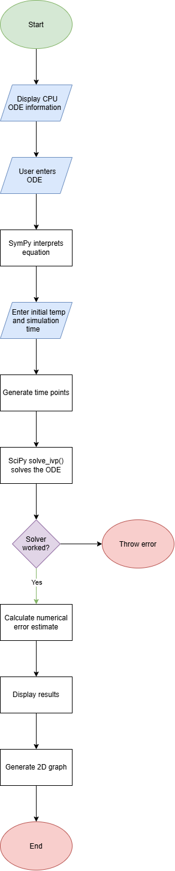
7. Visualization
The program uses a 2D line graph to represent the numerical solution.
The x-axis represents:
$$\text{Time (seconds)}$$
The y-axis represents:
$$\text{CPU Temperature (°C)}$$
The graph allows the user to visually observe the CPU cooling process.
For the example:
$$T\left(0\right)={85}^{∘}C$$
and:
$$T_{a}={25}^{∘}C$$
the temperature begins at 85 °C and gradually decreases toward 25 °C.
The curve becomes less steep over time because the difference between the CPU temperature and ambient temperature becomes smaller.

8. Error Estimate
The program estimates numerical error by solving the same ODE twice.
The first solution uses:
Relative tolerance: 1e-6
Absolute tolerance: 1e-8
The second solution uses tighter tolerances:
Relative tolerance: 1e-10
Absolute tolerance: 1e-12
The two numerical solutions are then compared at the same time points.
The absolute difference is calculated as:
$$E\left(t\right)=∣T_{\text{normal}}\left(t\right)-T_{\text{high accuracy}}\left(t\right)∣$$
The largest difference is reported as the estimated maximum numerical error in degrees Celsius.
This provides an estimate of the numerical error produced by the solver rather than assuming that the numerical result is exact.
Insert screenshot of the terminal showing the error estimate here.

9. Program Execution Screenshots
The following screenshots should be included in the final documentation.
Figure 1 – Project Structure

Figure 2 – User Input
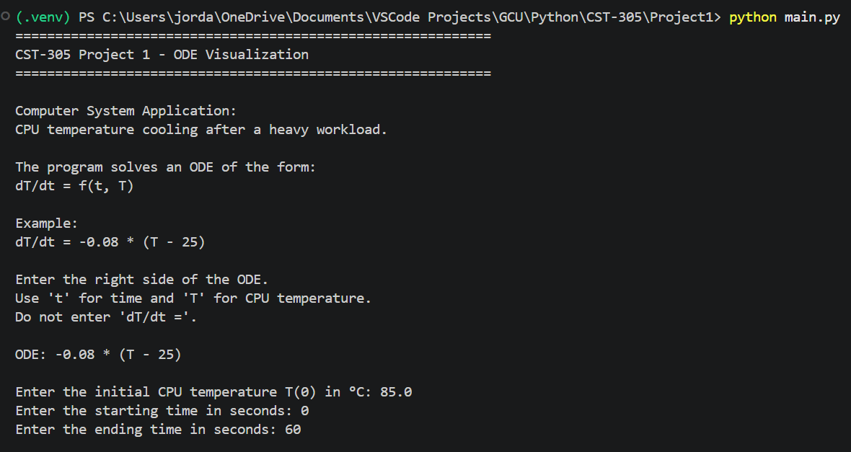
Figure 3 – Numerical Results
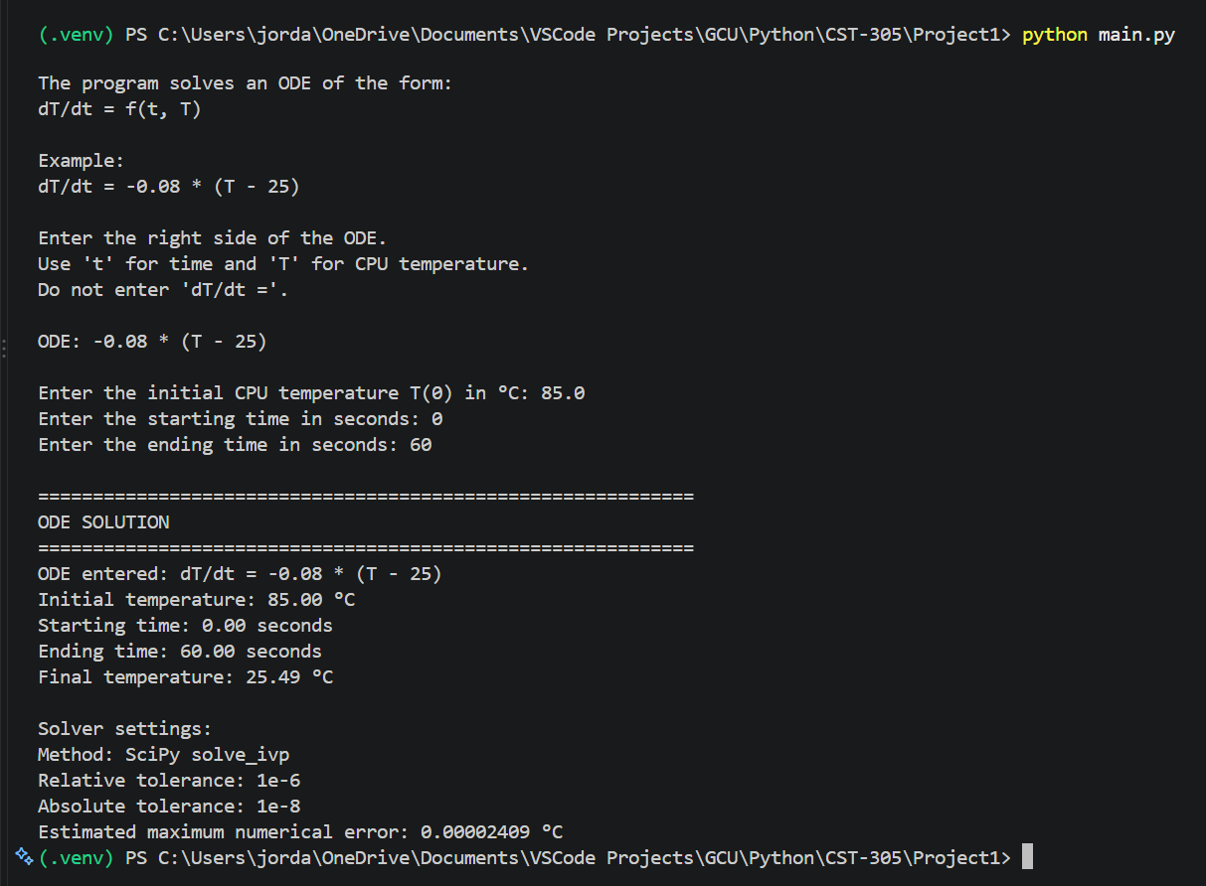
Figure 4 – Visualization
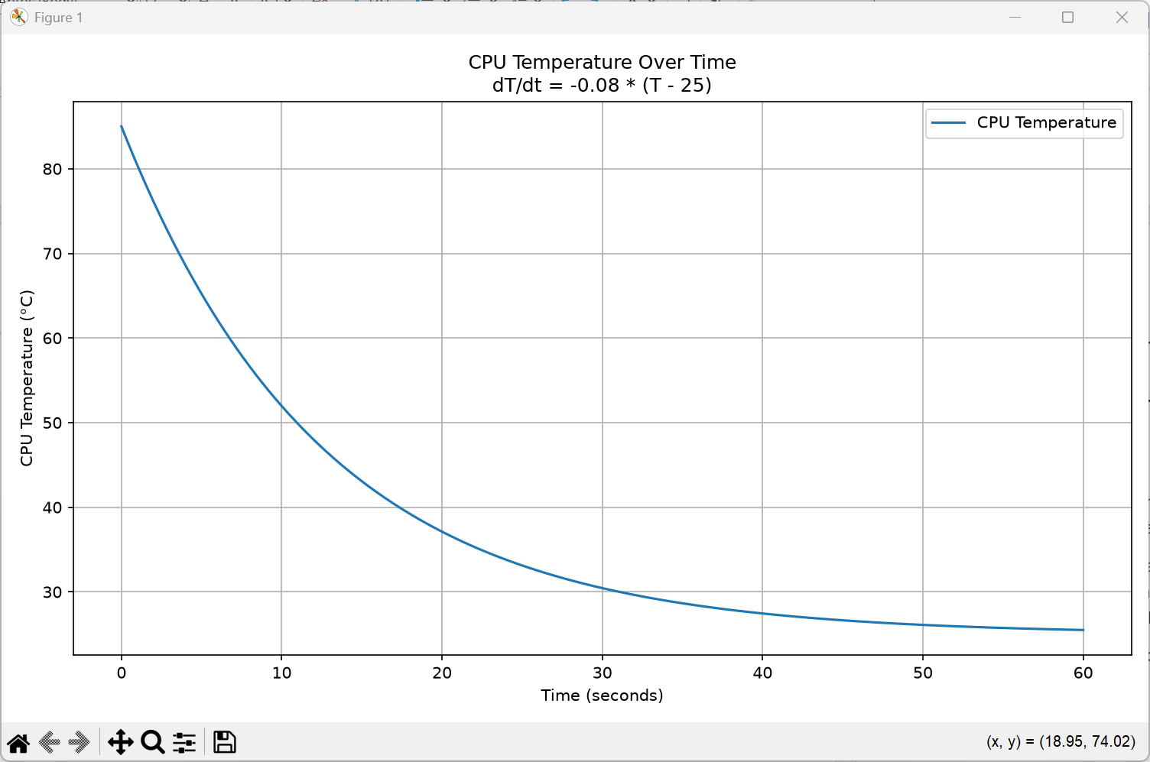

10. Results
Using an initial CPU temperature of 85 °C and an ambient temperature of 25 °C, the model predicts that the CPU temperature decreases over the 60-second simulation. The final temperature calculated by the program was 25.49 °C.
The temperature decreases rapidly at the beginning because the difference between the CPU temperature and ambient temperature is initially large. As the CPU approaches the ambient temperature, the rate of cooling decreases.
For the example equation:
$$\frac{dT}{dt}=-0.08\left(T-25\right)$$
the numerical solution follows the expected exponential cooling behavior.
The estimated maximum numerical difference between the standard-tolerance solution and the higher-accuracy solution was 0.00002409 °C. This small difference indicates that the numerical solution is stable for the selected solver tolerances.

11. References
SciPy developers. (n.d.). scipy.integrate.solve_ivp. SciPy documentation. https://docs.scipy.org/doc/scipy/reference/generated/scipy.integrate.solve_ivp.html
SymPy Development Team. (n.d.). sympify. SymPy documentation. https://docs.sympy.org/latest/modules/core.html
NumPy Developers. (n.d.). numpy.linspace. NumPy documentation. https://numpy.org/doc/stable/reference/generated/numpy.linspace.html
Matplotlib Development Team. (n.d.). plot. Matplotlib documentation. https://matplotlib.org/stable/plot_types/basic/plot.html

